**Minnesota Agricultural Education**

**Internship Application**

Summer 2025

Minnesota will once again be hiring Agricultural Education Interns in 2025. The purpose of the Agricultural Education Internship is to spark an interest in current collegiate students to consider entering the teaching profession and to provide Agricultural Education students with hands-on experience in this exciting career. The internship will focus on summer programing, such as Supervised Agricultural Experience (SAE) visits, county fairs, FFA leadership activities, and additional professional development opportunities.

The internship may begin as soon as May 12, 2025 and end as late as August 8, 2025; however, exact dates of the internship are negotiable. Interns will work approximately 320 hours over the summer (no more than 40 hours/week). One week of the summer will be spent at the Minnesota Association of Agricultural Educators (MAAE) summer conference, providing opportunities for professional development and networking. The conference will be held at Grand Casino in Hinckley, Minnesota from July 8-July 11, 2025.

The internship is intended for Agricultural Education majors, however, students in other majors who are interested in pursuing teacher licensure will also be considered. Current freshmen, sophomores, juniors, and initial licensure graduate students from any institution should apply; however, priority will be given to those with the intent to teach in Minnesota.

Interns will be compensated with a salary of $15.25/hour. Conference lodging, registration, and MAAE membership dues will be provided for the intern. Transportation and housing are the intern’s responsibility.

Minimum Qualifications:

* Candidate must be completing freshman, sophomore, or junior year of college and not have graduated from college or completed student teaching. Initial licensure graduate students will also be considered.
* Candidate should be an Agricultural Education major or have the intent to pursue teacher licensure.
* Candidates may be from any institution; however, priority will be given to those with the intent to teach in Minnesota.
* Candidate must be self-motivated, ambitious, and possess a strong desire to learn.
* Candidate must work well with youth and adults. The individual should be a strong communicator.
* Candidate must have a valid driver’s license and reliable transportation.

Internship Credits

Individual study credits may be available through your college or university. Please contact your institution to see if this internship will qualify for credit.

Application Process:

Candidates must provide a letter of interest, resume, and application, by **Monday, November 18, 2024** to opdah012@umn.edu. The selection committee will review applications and select individuals for interviews.

For more information or questions, please contact Kari Schwab at opdah012@umn.edu or 612-624-6256.

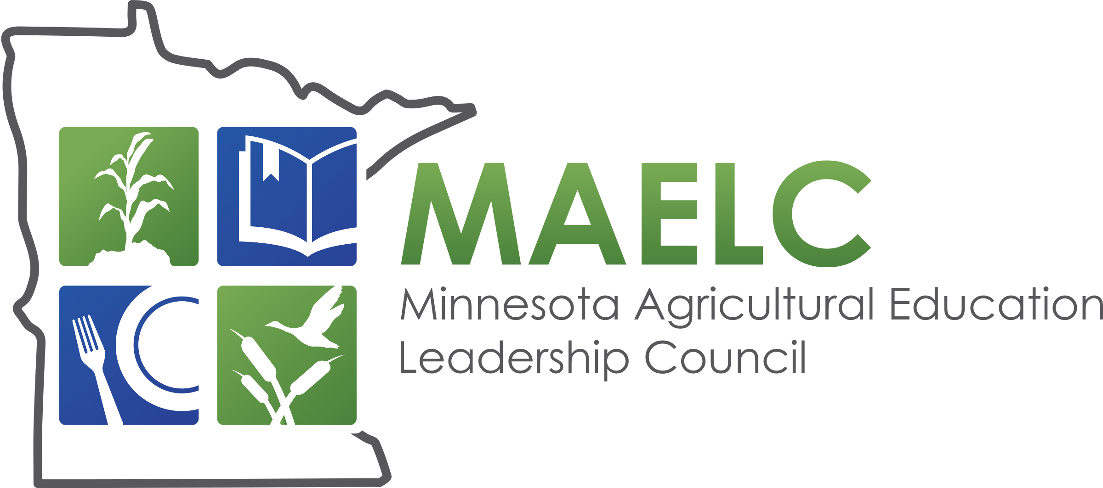

**Application for Minnesota Agricultural Education Internship**

*\*Applications are due by November 18, 2024. Please attach your letter of interest and resume.*

|  |  |  |  |  |  |  |  |  |  |  |  |  |  |
| --- | --- | --- | --- | --- | --- | --- | --- | --- | --- | --- | --- | --- | --- |
| Name: |  | | | | | | | | | | | | |
| College Attending and Expected Graduation Year: | | | | | |  | | | | |  | |  |
|  | | | | | | College | | | | | | Expected Graduation Year | |
| College Major(s)/Minor(s): | | | |  | | | | |  |  | | | |
|  | | | | Major | | | | | | Minor | | | |
| Permanent Address: | | | |  | | | | | | | | | |
| Cell Phone: | |  | | |  | | Email: |  | | | | | |
| High School(s) Attended: | | |  | | | | | | | | | | |
| Agriculture Teacher(s): | | | |  | | | | | | | | | |
| *\*If applicable* | | | |  | | | | | | | | | |

Please indicate your top three choices for which Minnesota FFA Region (Region 1-Region 8) you would prefer to be located. A map of the eight regions is attached; a specific list of chapters within each region can be found at: https://www.mnffa.org/chapter-directory.

|  |  |
| --- | --- |
| 1st Choice Region: |  |
| 2nd Choice Region: |  |
| 3rd Choice Region: |  |

*\*Keep in mind, you are* ***not*** *guaranteed placement in the regions you identify. Transportation and housing during your internship are your responsibility, however, cooperating teachers have typically been willing to assist in finding options.*

**Please answer the following questions:**

1. Please briefly explain your interest in becoming an agriculture teacher and include your experiences in Agricultural Education thus far as a high school and/or college student (classroom, SAE, FFA, community outreach, etc).
2. What do you hope to learn from this internship? Please share if there are any specific experiences you hope to gain during the summer (ex. agricultural mechanics, greenhouse management, SAE visits, classroom set-up advice) *Note – due to the timing of this internship, there are limited opportunities for classroom instruction.

*\*\*NOTE-Some programs may have changed, however, it will give a general idea of the FFA region geography.*

*Region 1-Pink, Region 2-Light Blue, Region 3-Dark Blue, Region 4-Dark Orange, Region 5-Light Orange,*

*Region 6-Yellow, Region 7-Peach, Region 8-Green*

